|  |
| --- |
|  |
| City of Los Angeles 2015-2016 My311 Service Request Data Analysis Report  USC Marshall School of Business |
| |  |  |  | | --- | --- | --- | | Jie Chen, Patrick Yu, Danny Cheng, Xiaoqiu Yu, Xueting Yan, Yiding Zhang | 12/7/16 | DSO 545 – Group 7 | |

City of Los Angeles My311 Data Analysis Report

# Introduction

The 3-1-1 is single point of contact system to provide a proactive way by city of Los Angeles to listen to the need of their residents and help them. It’s part of eGovernment initiative to deliver better service to citizens by simplifying their interaction with municipal agencies. Originally, 3-1-1 is just a telephone number that provides access to non-emergency municipal services. From Apr. 2013, MyLA311 App became available to submit service requests with mobile phones as well. Besides, 3-1-1 service can also be conveniently accessed through Email, 311 websites and other channels. With more channels to access 3-1-1 services, the city of LA should pay more attention to ensure better quality service with the less cost and resources.

With this goal in mind, this project is to help city of Los Angeles to analyze 2015-2016 My311 service request data, find the trends and draw insights together with LA’s geographic, demographic data, and try to predict future trend of 311 services. Furthermore, we will provide preliminary recommendations to the city of Los Angeles to improve their 3-1-1 service and provide better living experience to their tax payers and residents.

# Methodology

## Data Source

The data source we use in this project is downloaded from official city of LA website (data.lacity.org).

**Data Source**: <https://data.lacity.org/A-Well-Run-City/MyLA311-Service-Request-Data-2016/ndkd-k878>

**Data Range**: 2015-08-05 06:09:44 UTC to 2016-11-30 23:58:34 UTC

**Number of Observations**: 1,111,575

## Analysis Tool

We use R programming language to clean data, analyze data and draw charts. The R packages we used for this project are ggplot2, dplyr, lubricate, ggmap, maptools, tseries, stats, and forecast. Then we find insights from the analysis results and charts.

# Findings

## Overall trend of 3-1-1 requests

### The LA residents tends to be more aware of 3-1-1 system.

From Figure 1, we can see that, overall, the number of service request is increasing. Noticeably, the number of service request started to increase dramatically from Jan. 2016.

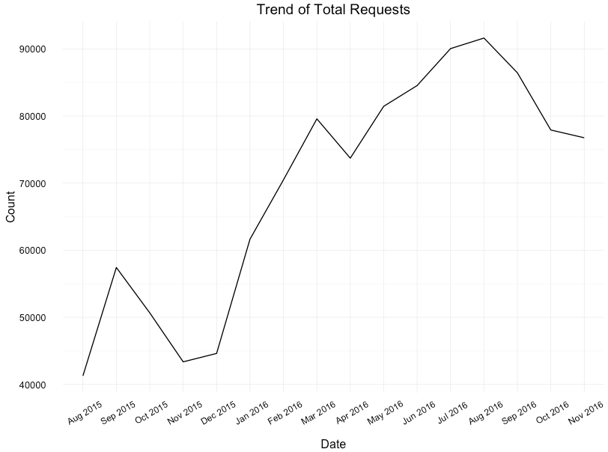

Figure

### The sudden request increase is due to a newly added category “Graffiti Removal”, not a sudden increase in issue.

If we breakdown these requests by Request Type, which shows in Figure 2 and 3, there is a new category “Graffiti Removal", contributing most to the sudden increase from Jan. 2016. Besides, “Other” in Figure 4 also shows an unusual growth, which we suspect may due to change of categorization. (Minor Request Type stands for request types that exclude “Bulky Items” and “Graffiti Removal”)

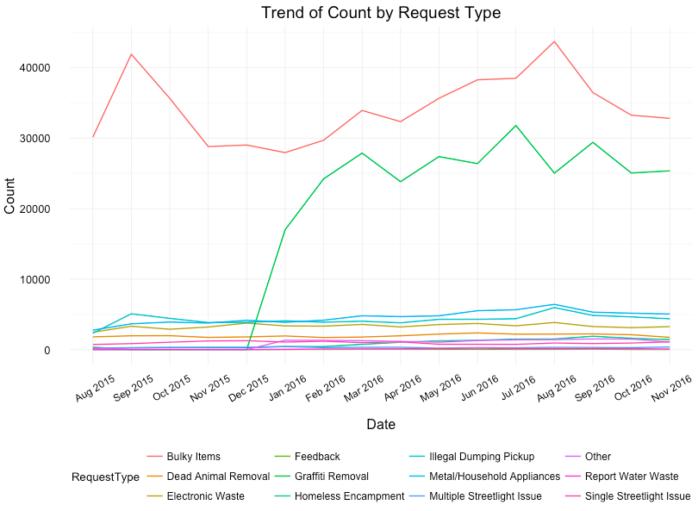

Figure

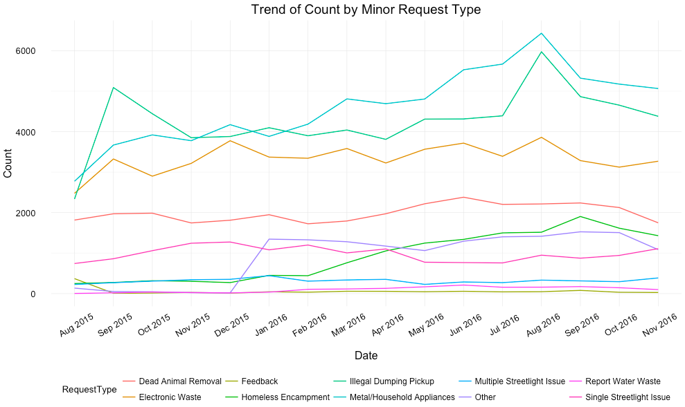

Figure

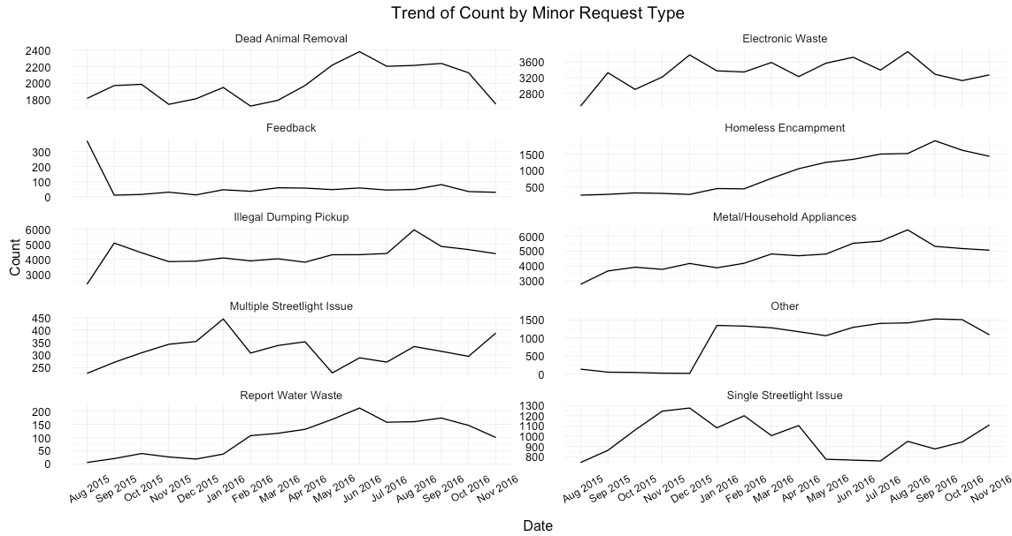

Figure

If we remove “Graffiti Removal” and “Other”, we can still observe an increasing trend (Figure ). The increase was about 12% (from approximately 58k in Aug. 2015 to approximately 65k in Aug. 2016). Potential reasons could be:

* More people are aware of 311 app (launched from Apr. 2013).
* More people are aware of 311 service itself.

### The peak season is aligned with school’s move-in-out months, while the off season is when people have their winter holidays.

The peak is from May to August. The reason behind might be that it’s the school’s move-in-out season. Figure 4 is an alternative to Figure 3. From Figure 2 and 3, we find increases in relevant requests during that period, including “Bulky Items”, “Illegal Dumping Pickup”, and “Metal/Household Appliances”. This finding supports our speculation.

The off-season is during Nov.to Dec., which is holiday season. Since people may go travelling, less requests are made.

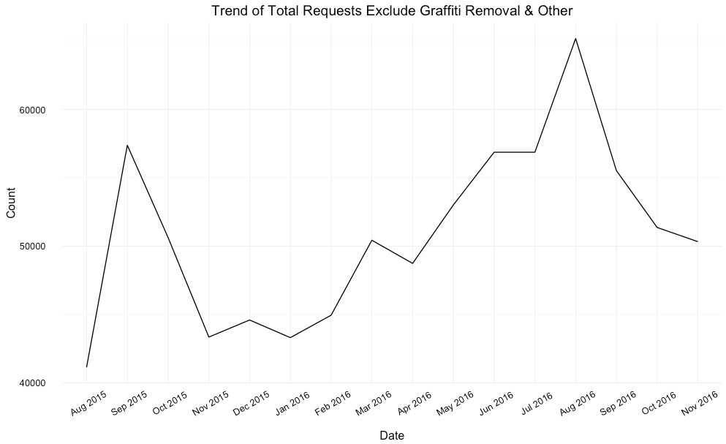

Figure

## Why do citizens call 3-1-1?

### Bulky items and graffiti removals are the two most common issues.

Bulky item and Graffiti removal are the leading service request category, representing approximately 75% of all service requests (Figure 7).

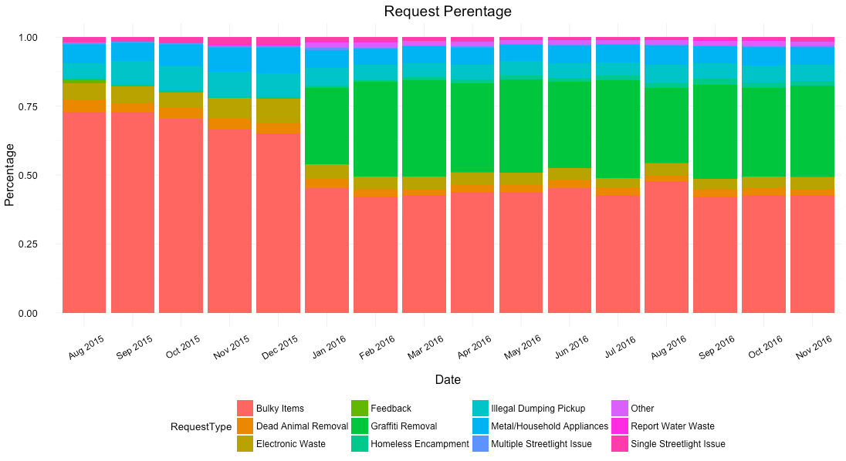

Figure

Across the top five request sources, “Bulky Items” and “Graffiti Removal” are still the two most commonly mentioned issues. Interestingly, for request created through “Driver Self Report”, 97% of them are for “Graffiti Removal”. Besides, “Electronic Waste”, “Illegal Dumping Pickup”, “Metal/Household Appliances”, “Streetlight Issues”, and “Water Waste” are also major reasons that citizens call 3-1-1.

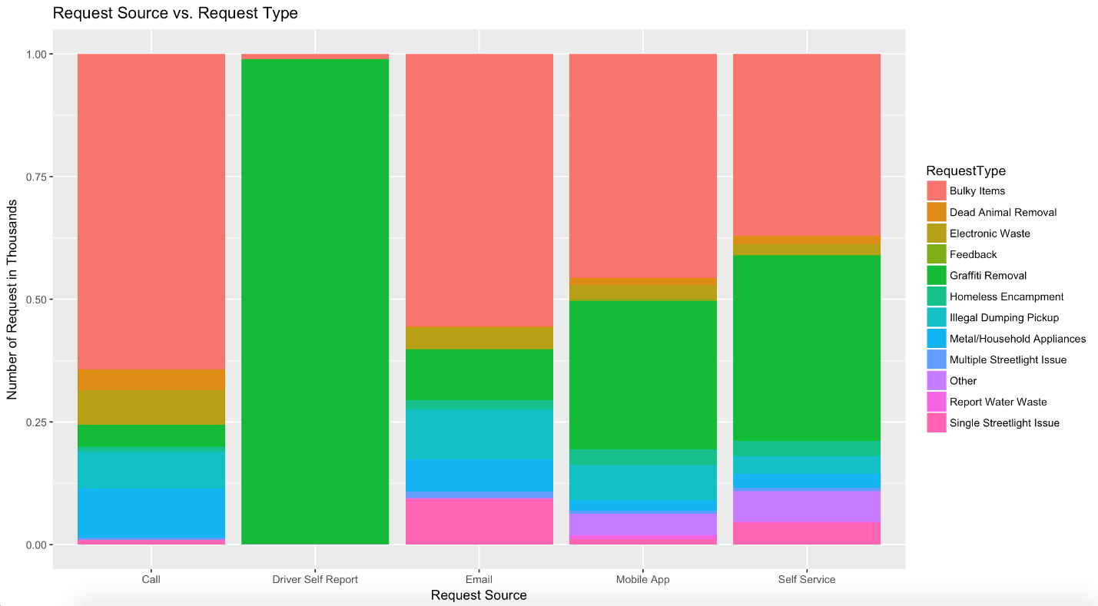

Figure

Bulky Items Request are forward to BOS, and Graffiti removal requests are to OCB. This Explains why BOS and OCB handle most of requests (Figure 9).

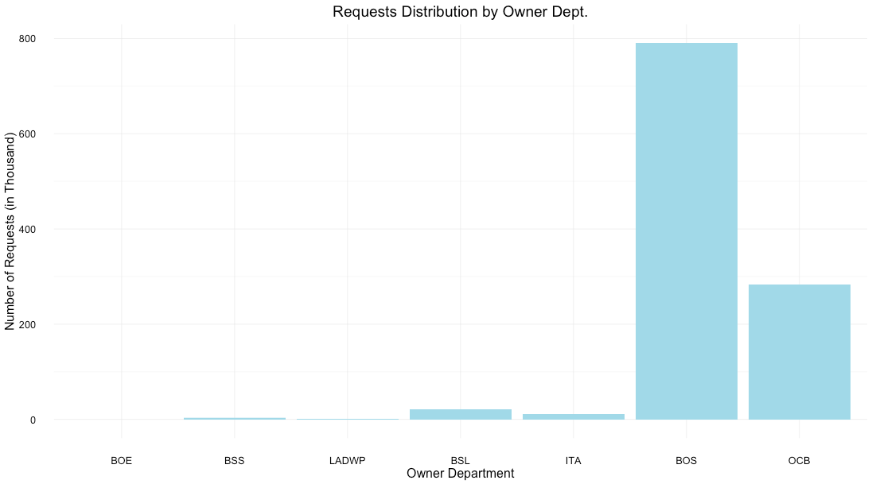

Figure

### The increase of “Bulky Items” requests around the USC area from May to August leads to the increase in total requests.

In the distribution map of Bulky Item requests per household by zip code (Figure 10), we can see most areas have values lower than 0.2, except some certain areas with values higher than 0.6. Households in these areas incline to generate relatively more Bulky Item requests. As we dig into where these areas specifically are, it turned out they are areas in USC neighborhood. It is reasonable that students moving in and out school would generate more requests of bulky items disposal.

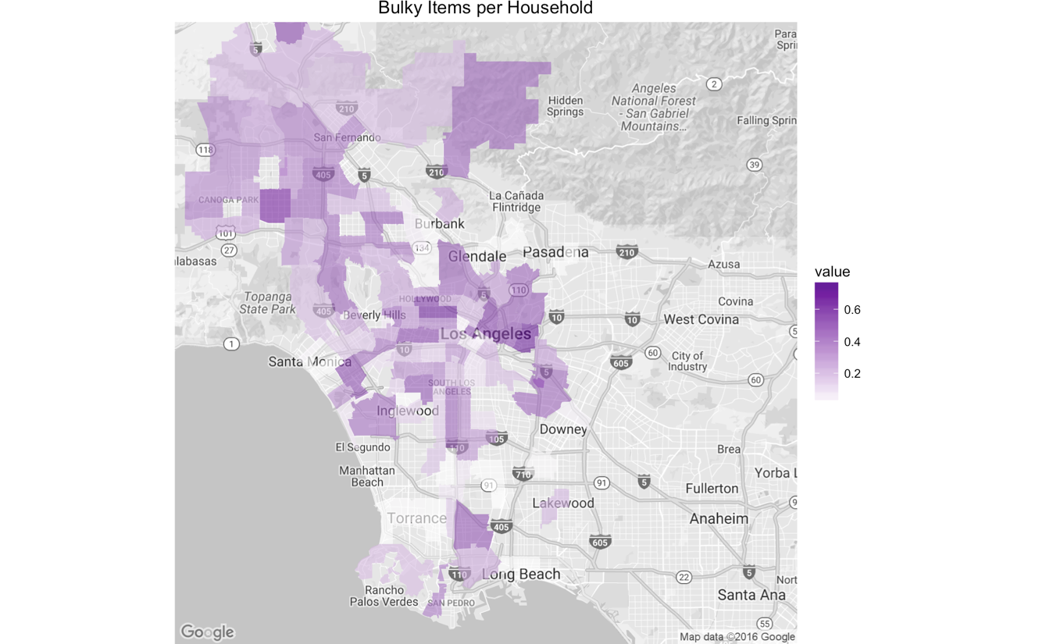

Figure

## When do citizens tend to report to 3-1-1?

### The number of service requests peaks on Mondays from 8:00am to 3:00pm, and decrease gradually in the following week days. People tends not to report issues during weekends through calls, but through other unattended ways.

The reason behind could be 1) people who have requests during weekend would like to wait until Monday to report, or 2) requests sending in during weekend will be together dealt with on Monday. We would suggest 311 Center get prepared for a relative high volume of requests coming in on Monday morning.

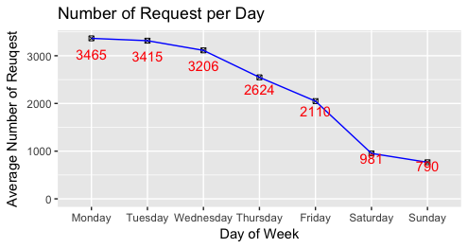

Figure

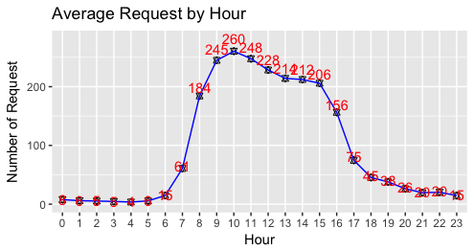

Figure

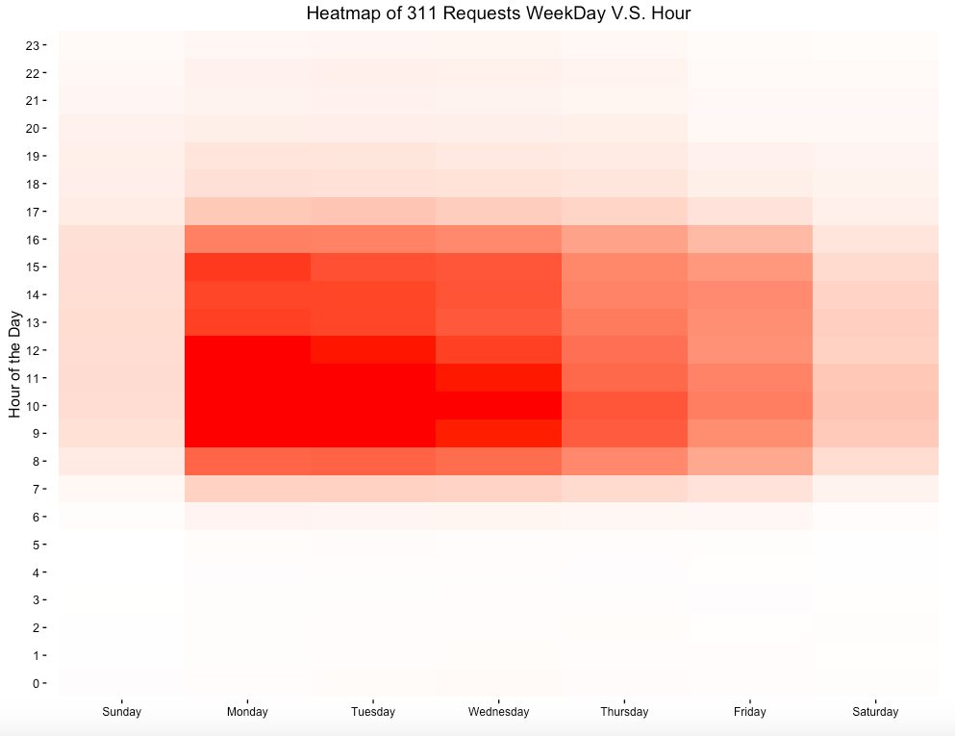

Figure

After exclude “Driver Self Report” requests which reported by the service technicians themselves and other request sources with very few requests, we can still see this downward trend from Monday to Sunday. The steep downturn on the number of service request created during weekends probably because the call center is understaffed during weekends. So, people tends to report through other unattended ways on weekends, such as Mobile App, Self Service and Email, from where we can see much less decrease in percentage.

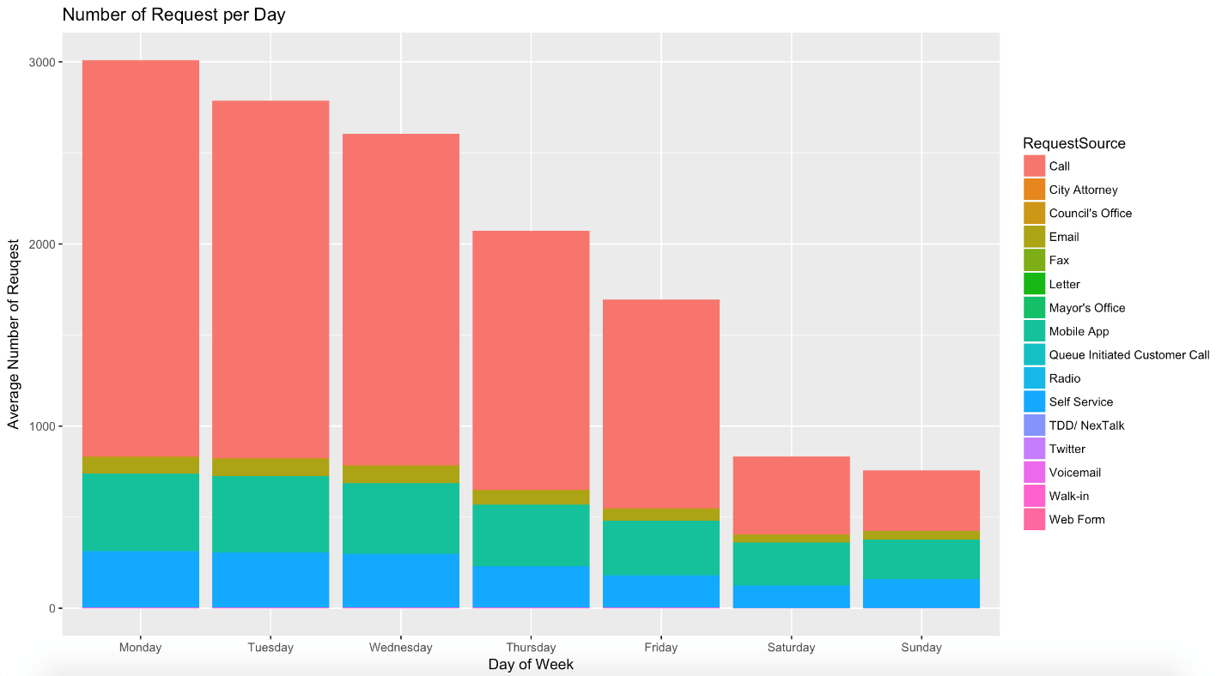

Figure

## What are the most preferred ways for citizens to call 3-1-1?

### Citizens still prefer phone call as the most straight forward way to communicate with city hall. With the growing population of millennial, other popular platforms, such as Mobile App, Online Self-service and Email, are becoming more and more popular.

Request source is the channel through which users file claims and report issues. 17 sources are recorded from April 2015 to November 2016. In this project, we explored request sources with respect to time (hour, month, day of week), request type and area to discover citizen’s preferences.

Data shows that Call, Driver Self Report, Mobile App, Self Service, and Email are the five major sources via which people use most frequently, representing more than 90% of the total requests, while City Attorney TDD/Next Talk, Radio, Mayor’s Office, Letter, and Twitter have very few observations.

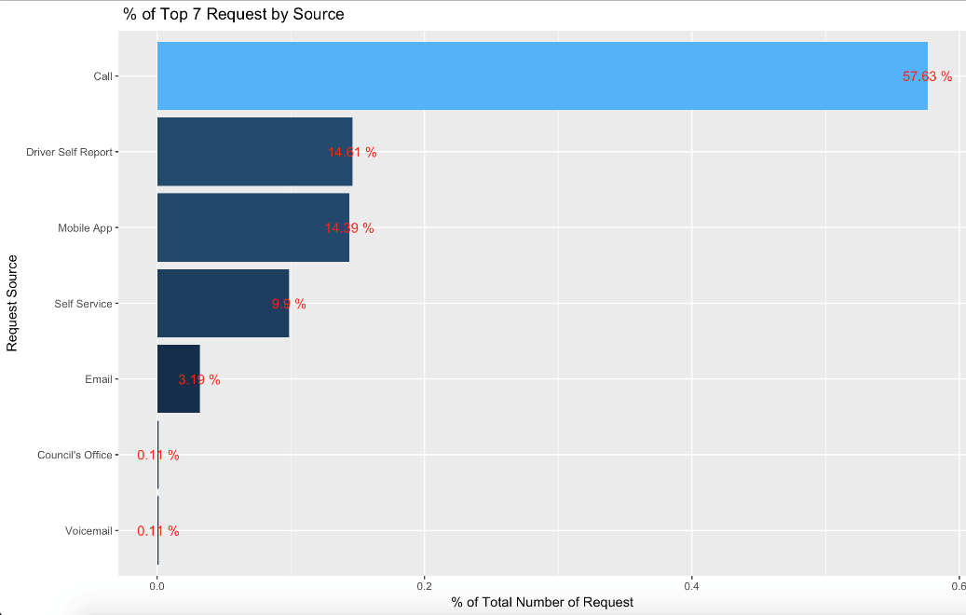

Figure

Central LA area has more millennial and tend to use self-service and mobile apps.

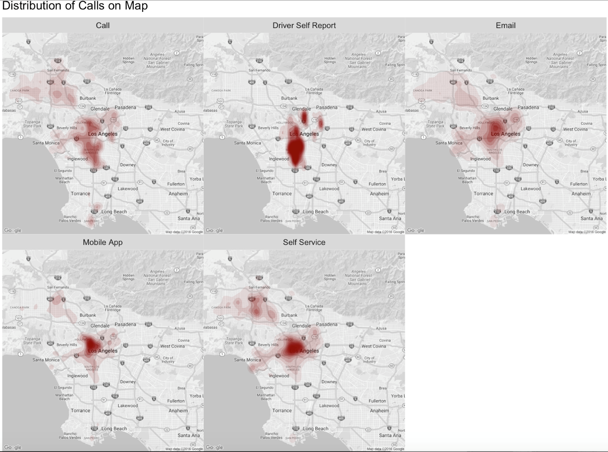

Over 50% of total requests are reported by Call, but there is a trend of declining as of percentage. Although there’s big drop in the number requests created through mobile app during Nov. - Dec. 2015, there’s a drastic increase of requests created through Email. The decrease in mobile app requests and the increase Email requests is complementary.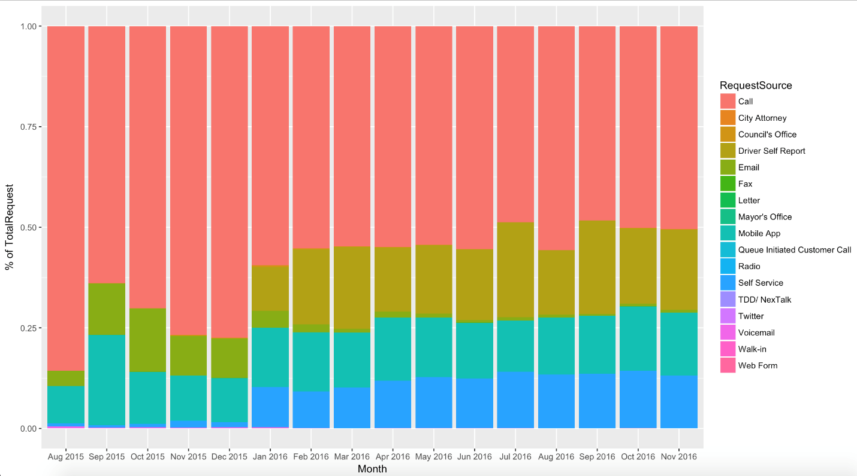

Figure

## Any behavioral differences among 3-1-1 callers from different area?

### Generally, the distribution of 3-1-1 service requests is in proportion to the population distribution. However, the outstanding type of issue varies for each clustering geographic area.

we can see that request volume and population of each zip code area generally have positive correlations. Zip Code areas with relatively larger population also have higher request volumes, which mainly concentrate in Central LA, San Fernando, and San Pedro.

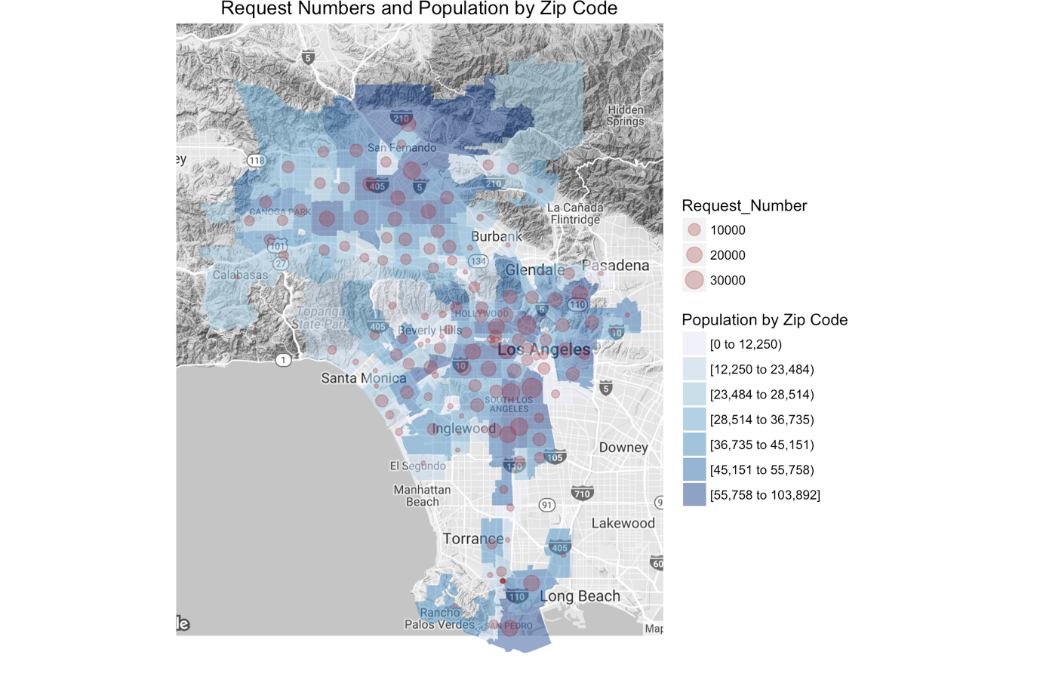

Figure

There’s a concentration of service request in Korea town area. This is expected as there are more people living in that area compared to other areas. Per Los Angeles Times, Koreatown is a neighborhood with 42,611 people per square which is the highest population density in the Los Angeles area[1]. This population density has contributed to the high volume of calls in the area.

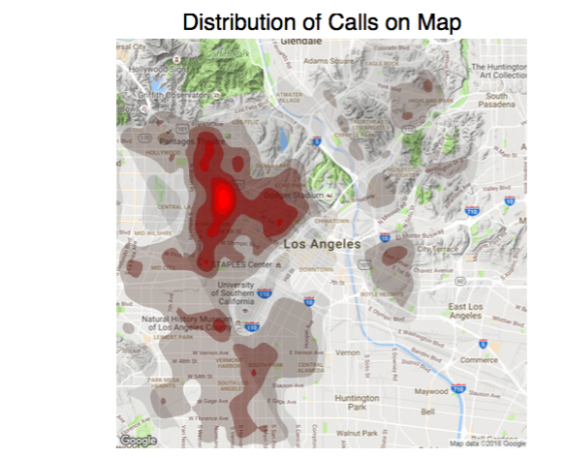

Figure

Per the density maps of different request types, the distributions of all different request type mostly positively correlate with population. The distribution of bulky items is fairly spread out in the Los Angeles area with more concentration on the Koreatown; “Graffiti Removal” is mostly in the heavily populated areas such as Koreatown and Hollywood. This may because may graffities tend to appear in places where people are active; some of the graffities may be contributed by homeless people, the density of which is also in the Koreatown area. Downtown and south of USC are also the hot spots of homeless encampment. Streetlight issues are mostly centered on downtown area. The reason for such focus may be that there is more night life, more on-purpose destructive activities and more night stores in that area, thus that streetlights are more likely to be damaged and reported.

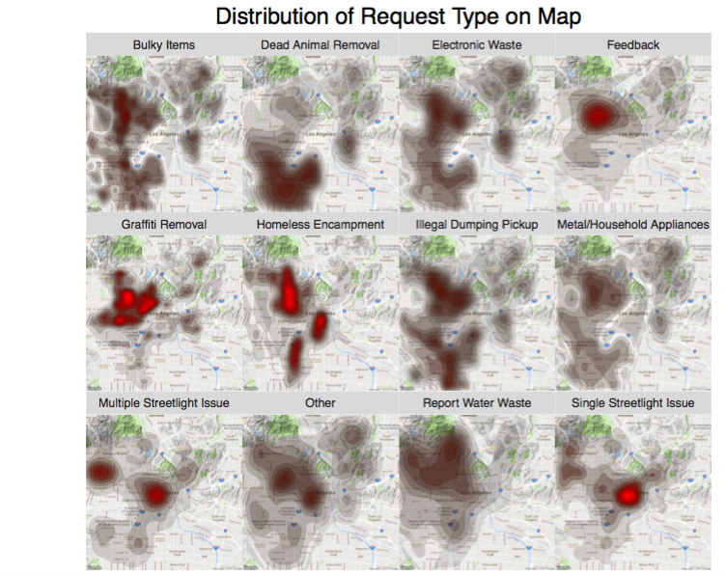

Figure

From Figure 9 above, we can observe that:

1. Metal/Household Appliance, Electronic Waste, Illegal Dumping Pickup has similar distribution pattern to Bulky Items. They can be categorized as Disposal Service, and happen in area having most households.
2. Illegal dumping pickup and Homeless Encampment distribute in similar areas, maybe because homeless tends to dump illegally.
3. “Street light” issue concentrate in downtown, probably due to more nightlife and shops being more aware of streetlight issues.

We also want to explore if there are some similar request patterns among certain areas. Thus we used K-means clustering (K = 5) to segment zip code areas in LA by numbers of each request types.

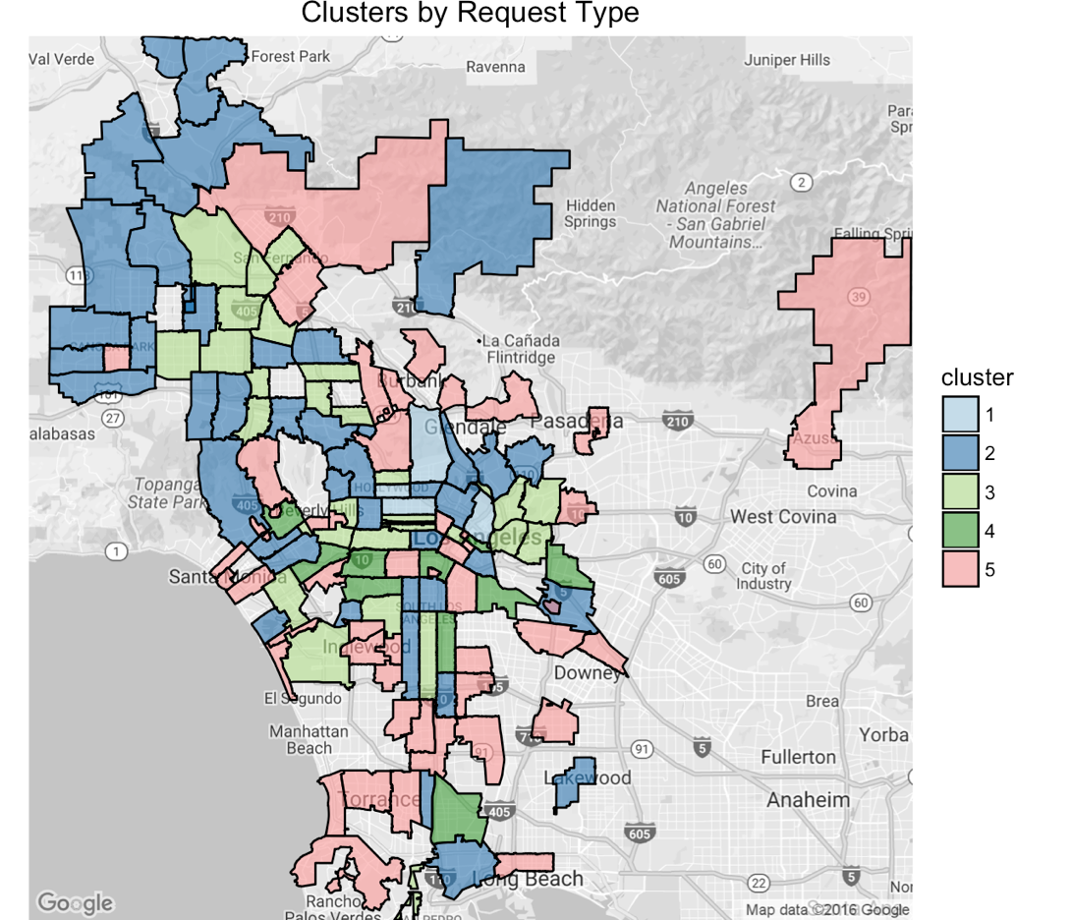

Figure

The means of each request type in different area clusters show as below.

Table Average number of different types of requests of each area cluster

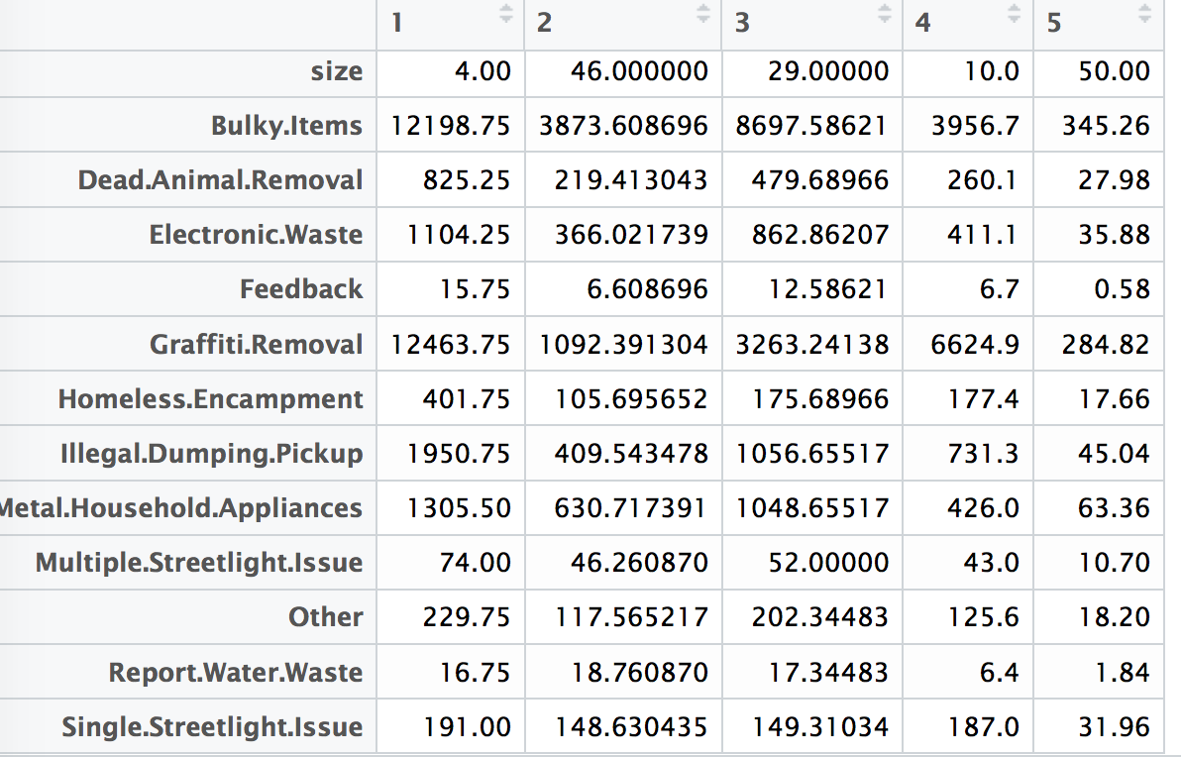

We can identify obvious variation through different clusters.

* Cluster 1, which consists of only 4 light blue zip code areas, have remarkably higher volumes of requests. Most of them are “Bulky Items” and “Graffiti Removal”. Thus bulky item disposal and graffiti problems in these areas might be severe.
* Cluster 2 has largest size, which has 46 zip code area in dark blue color. Similarly, bulky items and graffiti removal are the most common types.
* In Cluster 3 of areas in light green, request numbers of bulky items, graffiti removal, illegal dumping pickup and metal household appliance have relatively similar scales.
* In Cluster 4 of areas in dark green, request numbers of graffiti removal are approximately 1.7 times of that of bulky items.
* Cluster 5 has relatively smaller scale of overall request number.

Per clustering result, we got a grasp of the overall scale and structure of volumes of different request types for most zip code areas (cluster 2 and cluster 3). Also, special attention should be paid to the areas in cluster 1, which generate considerably higher volumes of bulky items and graffiti removal requests.

### Area around universities generate more “Bulky Item” requests.

In the distribution map of Bulky Item requests per household by zip code (Figure 21), we can see a majority of areas have values lower than 0.2, except some certain areas with values higher than 0.6. Households in these areas incline to generate relatively more Bulky Item requests. As we dig into where these areas specifically are, it turned out they are areas in USC neighborhood. It is reasonable that students moving in and out school would generate more requests of bulky items disposal.



Figure

### There are more illegal graffities in LA downtown area.

Since the start of “Graffiti Removal” service, the total request number stays high. This type of requests concentrates in central Los Angeles (Figure 11), where has a lot of graffities.

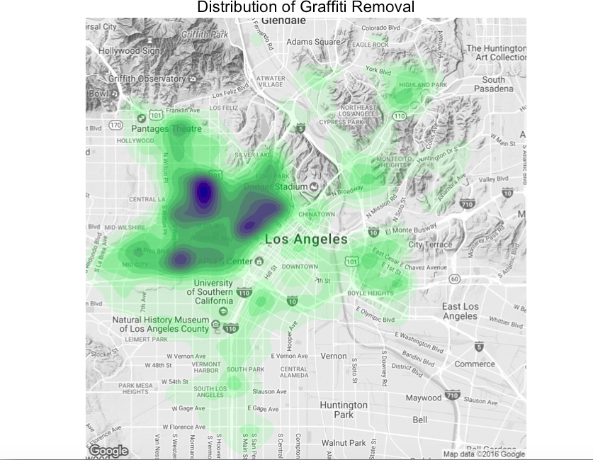

Figure

## How long does it take to process a 3-1-1 request?

### Over 96% of service requests have been closed, but requires more attention on feedbacks.

Over 96% of all requests are closed, which is neat. Breaking down into each month, we found that around 50% of requests remained “Open” in Aug 2015. Those open cases turn out to be 334 Feedback requests. We recommend 3-1-1 Center go through these feedbacks to see if there are any follow up requests, or any opportunities for service quality improvement.

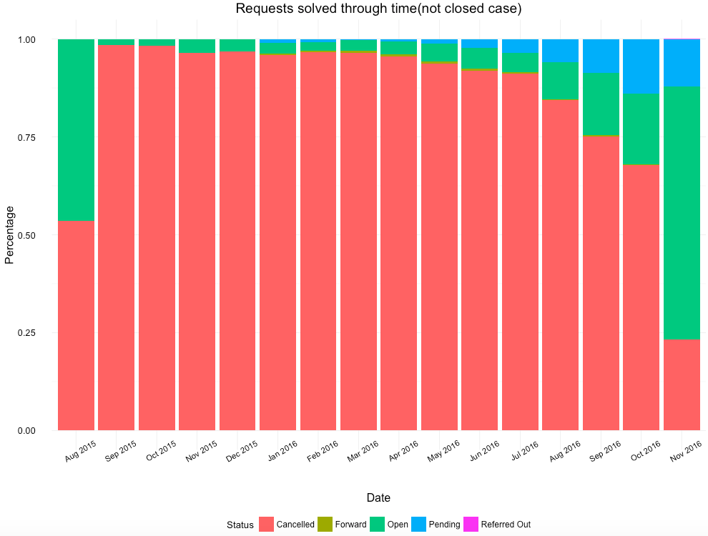

Figure

### On Nov. 2016, around 75% of service requests can be closed within 96 hours (4 days).

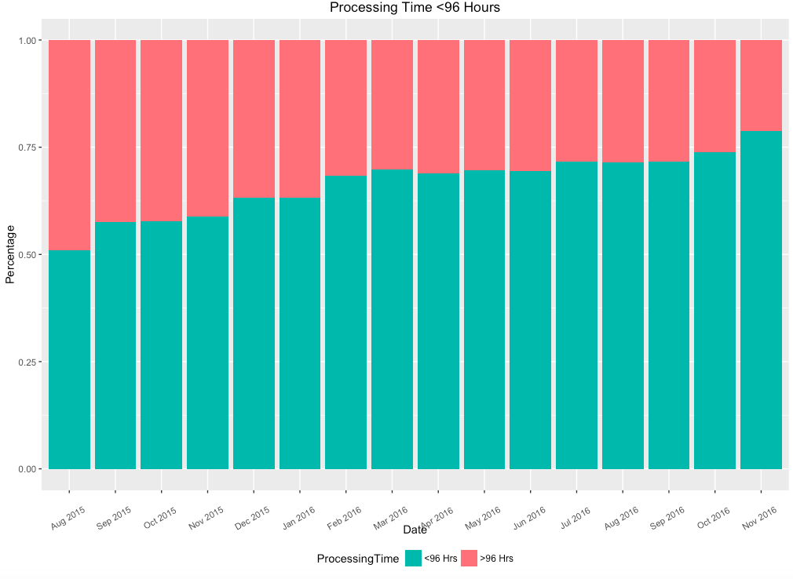

Figure

### Overall, the issue handling efficiency is increasing for all departments of city of LA.

From Figure 25, We can see from the graph that overall there is a trend of declining of processing time for most request types, which means that efficiency is increasing. Based on common perception, here we choose 72 Hours (3 days) as a benchmark, and get below observations:

1. Dead Animal Removal and Report Water Waster requests are mostly solved very quickly within 3 days. For Report Water Waster, the reaction is especially fast within less than 1 hour.
2. As Bulky Item is a request type that counts for half of all the requests, its processing time has obvious influence on overall processing time. We can see that there is a steady decrease of Bulky Item processing time, and in Nov 2016, it for the first time drop down **within 72 hours**.
3. Graffiti Removal as another main request type, also has significant drop in processing time since the year end 2015. Currently average processing time as around 2-3 days.
4. However, there are still several types of requests couldn’t be solved in time within 72 hours, such as Illegal Dumping Pickup and Homeless Encampment issue. This indicates the difficulties of solving these issues, Departments in charge such as BSS could think of new solutions and invest more labor to improve service efficiency.

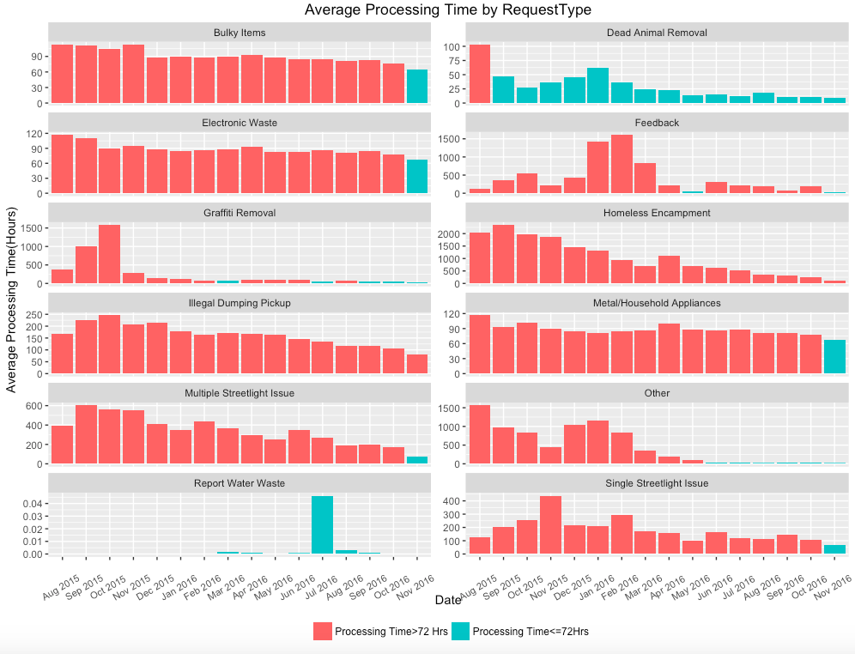

Figure 25

### The top 3 efficient departments are LADWP, ITA and BOE BOS.

From Figure 26, We can see that Top 3 efficient Dept. are LADWP, ITA and BOS. Their average processing time are 0.93 hours, 17.6 hours and 105.6 hours. (*BOE Dept. also has a low processing time of 2.1 hours, however it is a quite new department started only from Oct 2016)

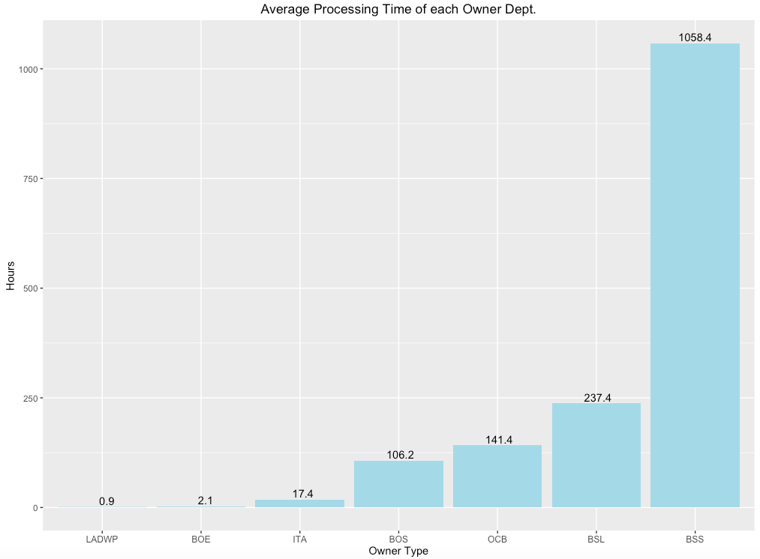

Figure

As shown in the above figure, BSS needs a relatively more processing time than other departments. With further analysis, we find that BSS is mainly in charge of Homeless Encampment issue, which is a type of request that often required longer processing time, as shown in following graph. The huge decline could be due to improvement of efficiency in dealing with Homeless issue, or a delayed update in the system before Jan 2016.

### Homeless issue needs further attention.

Other attention should be paid to Open and Pending cases. From Figure 27below, we can see that mainly “Homeless Encampment” and “Illegal Dumping Pickup” cases are “Pending”, department in charge should further follow up with these cases.

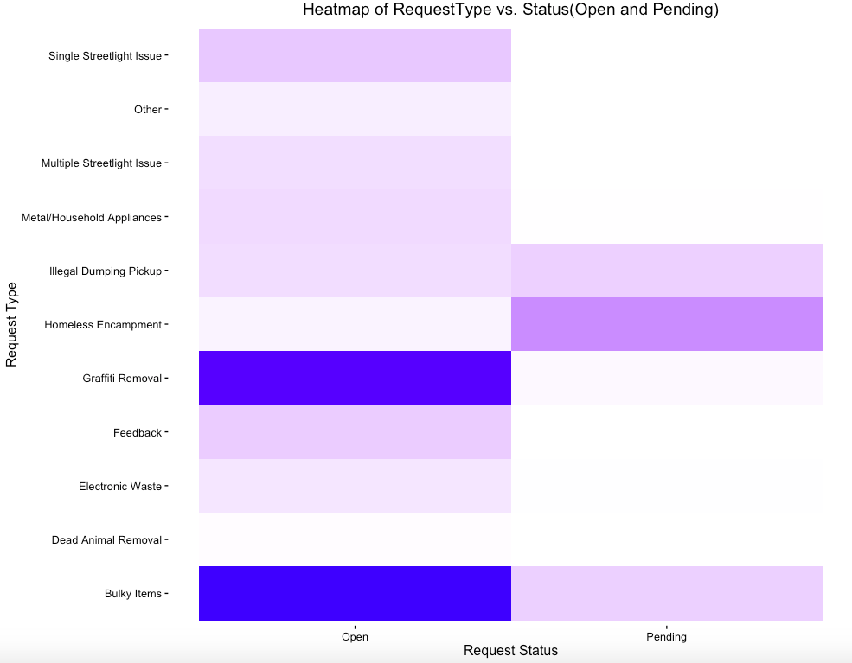

Figure

## Who owns the issue?

### The top 3 busy departments are BOS, OCB and BSL, who’s taking care of Bulky Items, Graffiti Removal and Metal/Household Appliance respectively.



Figure

### More specialized category should be added to “Other” requests

Currently different departments have their emphasis on dealing with different types of requests. However, we notice that several departments all deal with “Other” request, which could be vague and not enough efficient.

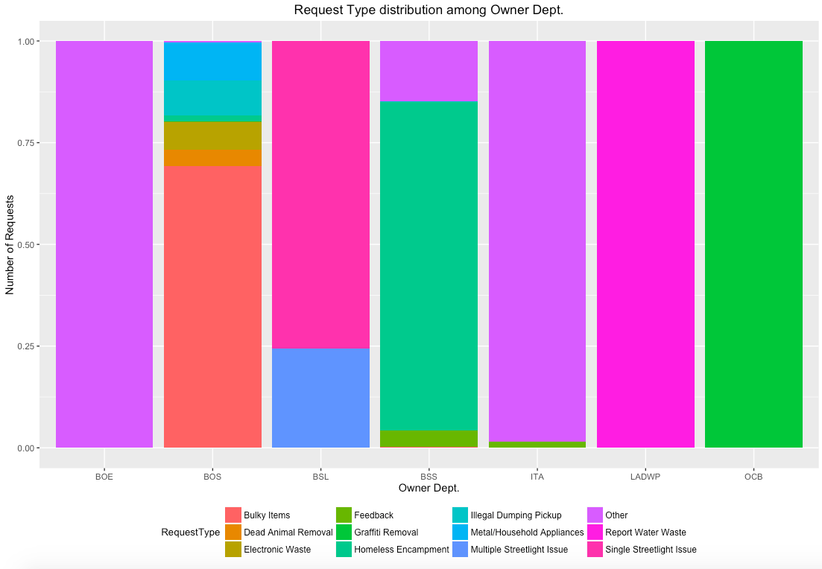

Figure

We believe that specialization will help improve efficiency.

1. Both BOE, BSS and ITA deal with uncategorized request. To improve efficiency, we can assign either one of the group oversee this kind of service.
2. We would suggest add more specialized category to break down “Other” requests.

## Let’s forecast future

We can see that there is a clear seasonal pattern from the graph on top of ACF and PACF graphs. The seasonal pattern reveals itself in the ACF graph in which the weekly season is shown. With this information, we transformed the date with seasonal differencing. After the transformation, the seasonal pattern disappears.

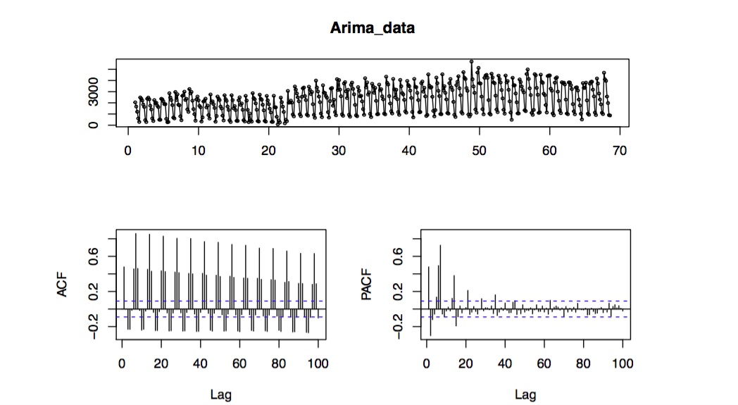

Figure

Based on the transformed time-series data, we built an ARIMA model of (0,0,1) (0,1,0) [7], which includes one-time weekly differencing and a lag of error.

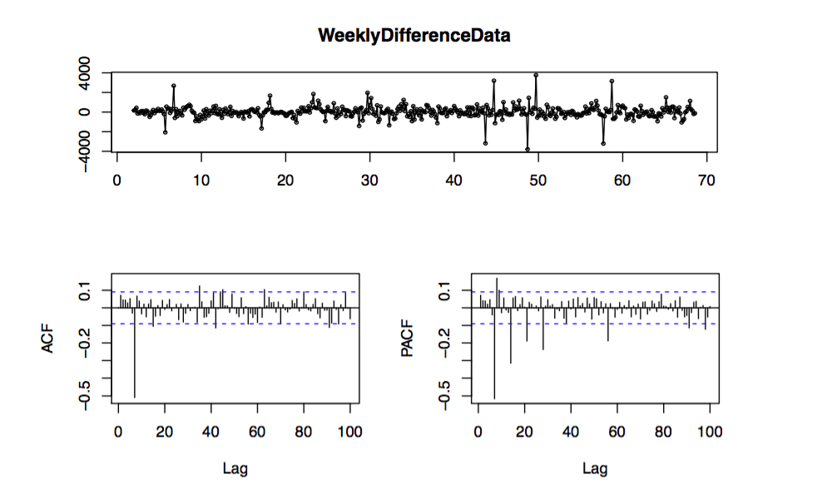

Figure

The blue line represents predictive values whereas the red line represents actual values. This ARIMA model is the best in terms of the Akaike Information Criterion Corrected(AICc), which measures prediction error and the complexity of the model. Since the ARIMA predicts one-week ahead, and every prediction after is the same. We will only present the prediction for next week here.

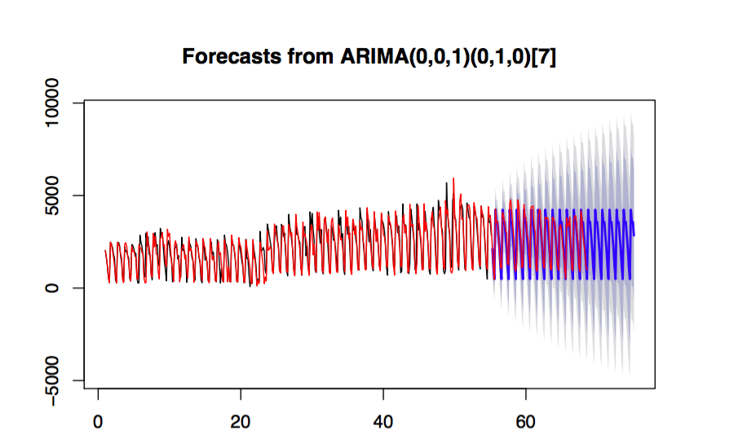

Figure

So, for each day of the next 20 weeks, the number of total service requests, service requests that come from phone call, the “Bulky Item” service requests, the “Graffiti Removal” service requests are forecasted as the tables below. We recommend the city of LA to use this forecasting data to allocate resources to process the service requests.

Table Forecast of No. of Service Requests on each Weekday for the Next 20 Weeks

|  |  |  |  |  |  |  |
| --- | --- | --- | --- | --- | --- | --- |
| Monday | Tuesday | Wednesday | Thursday | Friday | Saturday | Sunday |
| 4238 | 3557 | 3572 | 2837 | 2127 | 1132 | 484 |

Table Forecast of No. of Service Requests come from Phone Call on each Weekday for the Next 20 Weeks

|  |  |  |  |  |  |  |
| --- | --- | --- | --- | --- | --- | --- |
| Monday | Tuesday | Wednesday | Thursday | Friday | Saturday | Sunday |
| 2410 | 2255 | 1990 | 1639 | 1309 | 489 | 792 |

Table Forecast of No. of Service Requests come from Phone Call on each Weekday for the Next 20 Weeks

|  |  |  |  |  |  |  |
| --- | --- | --- | --- | --- | --- | --- |
| Monday | Tuesday | Wednesday | Thursday | Friday | Saturday | Sunday |
| 2267 | 1797 | 1692 | 1298 | 1084 | 509 | 193 |

Table Forecast of No. of Graffiti Removal Service Requests on each Weekday for the Next 20 Weeks

|  |  |  |  |  |  |  |
| --- | --- | --- | --- | --- | --- | --- |
| Monday | Tuesday | Wednesday | Thursday | Friday | Saturday | Sunday |
| 1904 | 877 | 339 | 250 | 1114 | 956 | 1147 |

# Recommendations

1. Allocate the resources solving 311 requests (customer service, government specialists responsible for 311 requests from each department, etc.) in correspondence with the population density in each area.
2. Encourage and promote the use of MyLA311 Apps and online forms instead of phone calls to reduce the resources required in call center, improve the information accuracy and the quality of service.
3. Add category triage function to call auto pickup system to shorten the call processing time and keep the caller busy while waiting.
4. The “Action Taken” column need to updated in time with more comprehensive content to accumulate knowledge base for request handling and data for future analysis.
5. Provide more disposal services in the area that have more households.
6. Add more specialized category to break down “Other” requests
7. More efforts should be paid on Illegal Dumping Pickup and Homeless Encampment. Both these 2 types of request have longer processing time and higher proportion of pending cases. Also, based on our observation and assumption, these 2 requests might be internal related, we would suggest relocate more manpower and resource on solving Homeless Encampment issues first.

# References

"Population Density." *Population Density Ranking - Mapping L.A.* Los Angeles Times, n.d. Web. 5 Dec. 2016.

1. "Population Density." *Population Density Ranking - Mapping L.A.* Los Angeles Times, n.d. Web. 5 Dec. 2016.